第七章课外作业

7.1.代码如下：

import keyword

s = keyword.kwlist#建立保留字列表

n = input('输入一个文件名：')

m = open(n,"r").readlines()

ls = []

for i in m:

i = i.split()

ls.append(i)

fo = open(n,"w+")

for i in range(len(ls)):

if i in s:

i = i

else:

i = i.lower()

7.2代码如下

from PIL import Image

im = Image.open("E:\\dog.jpg")

(w, h) = im.size

print(w,h)

nim = im.resize((160,120),Image.ANTIALIAS)

nim.save("E:\\newdog.jpg")

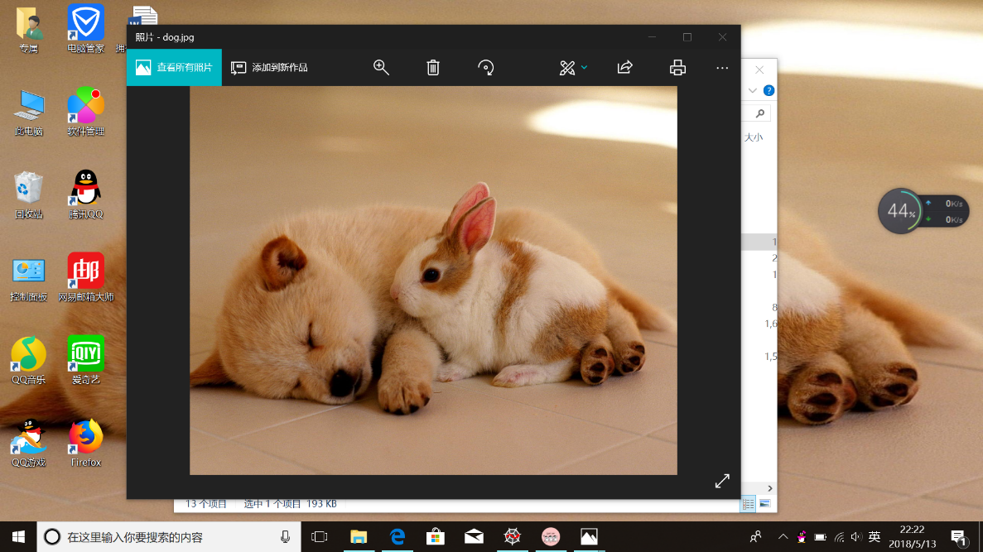

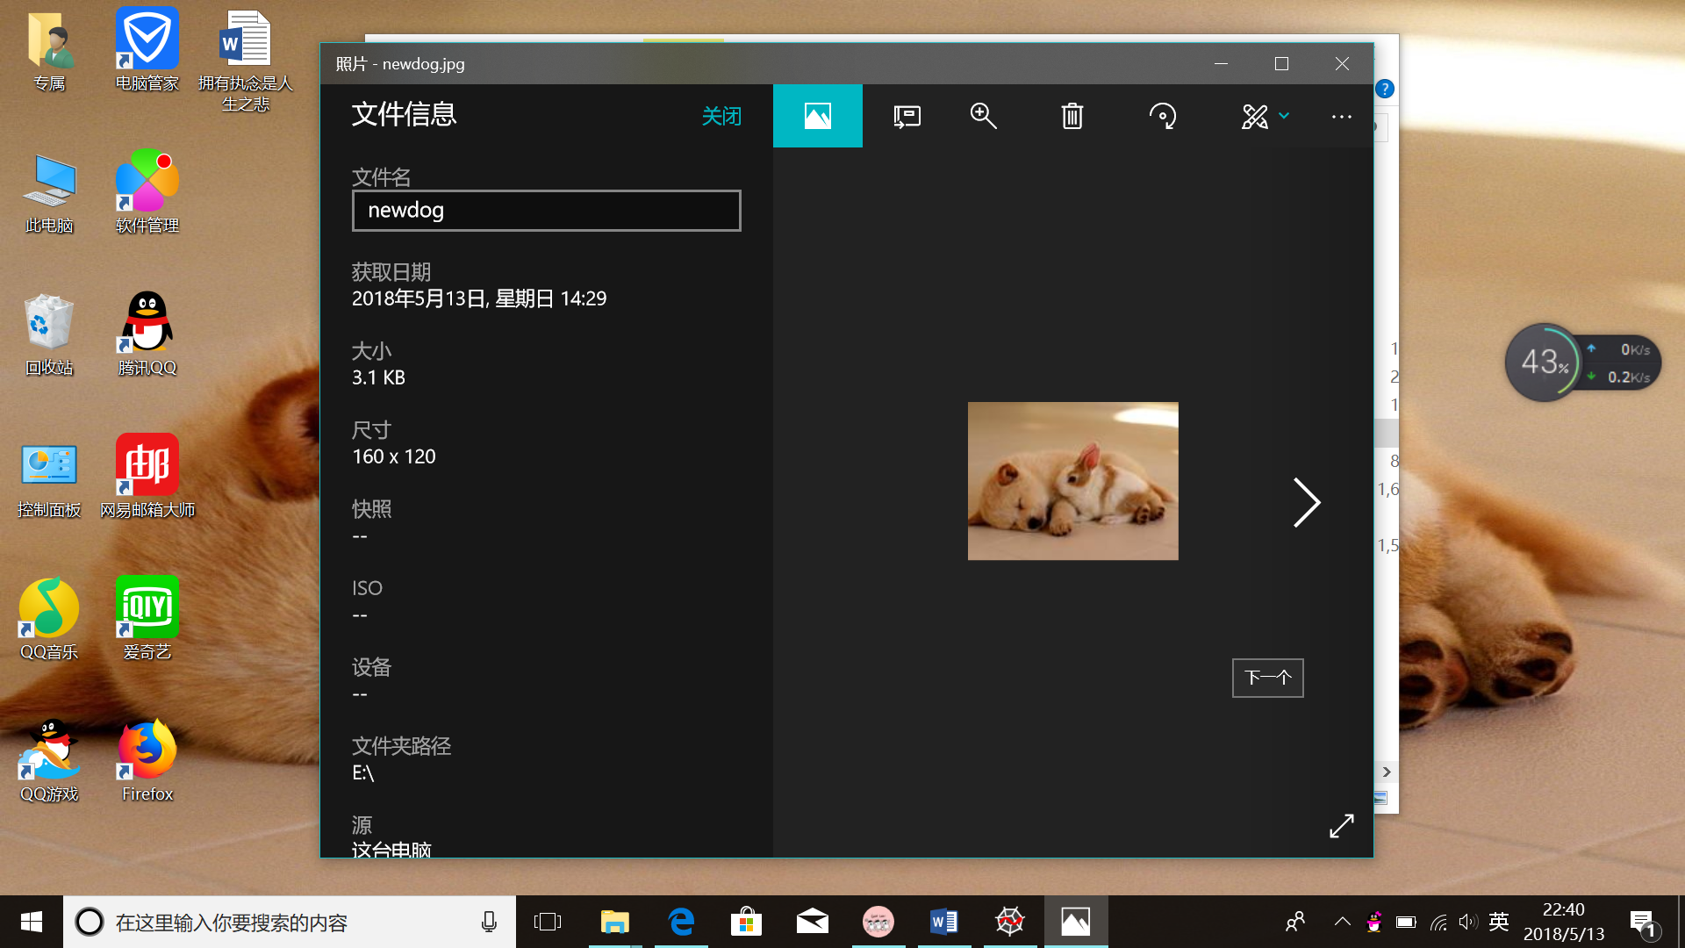

7.8代码如下

from PIL import Image

im = Image.open('E:\\dog.jpg')

r,g,b = im.split()

print(r,g,b)

newr = r.point(lambda i:i\*0)

om = Image.merge("RGB",(newr,g,b))

om.save('E:\\ndog.jpg')

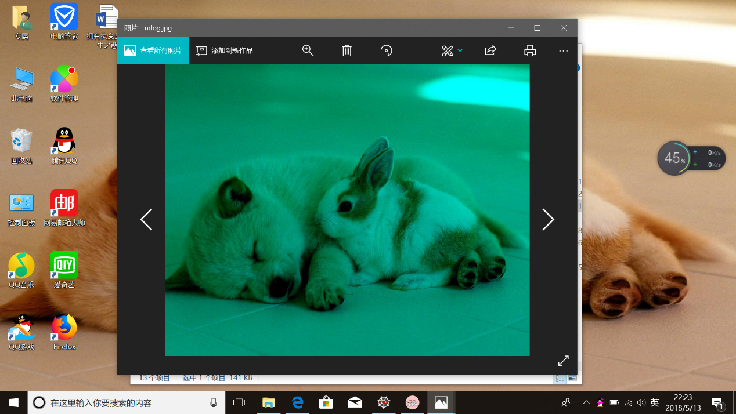

7.6 代码如下：

from PIL import Image

from PIL import ImageFilter

im = Image.open('E:\\person.jpg')

om = im.filter(ImageFilter.CONTOUR)

om.save("E:\\newperson.jpg")

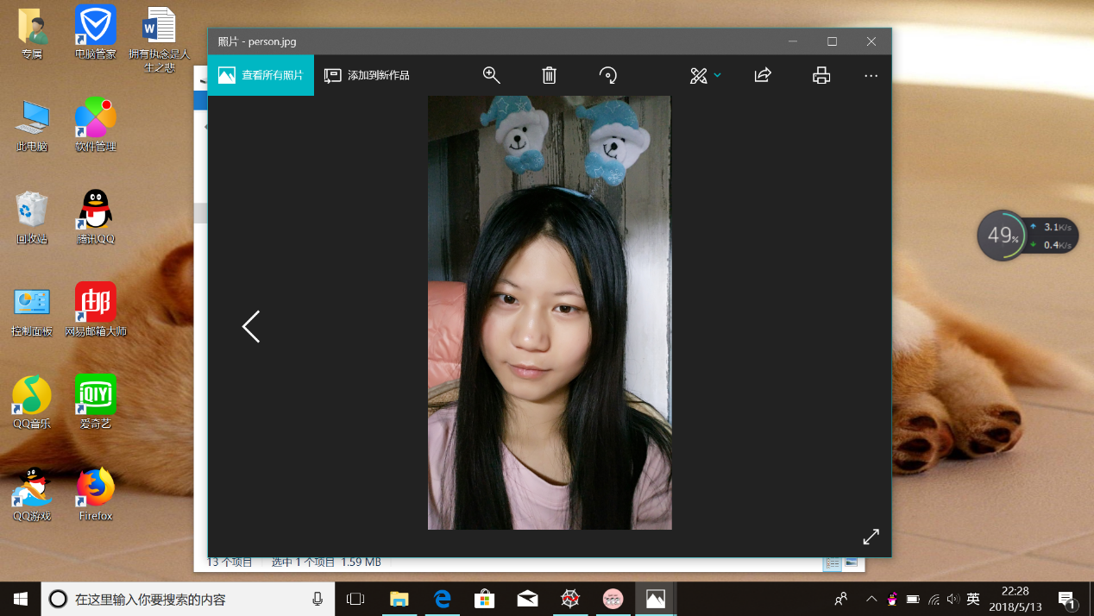

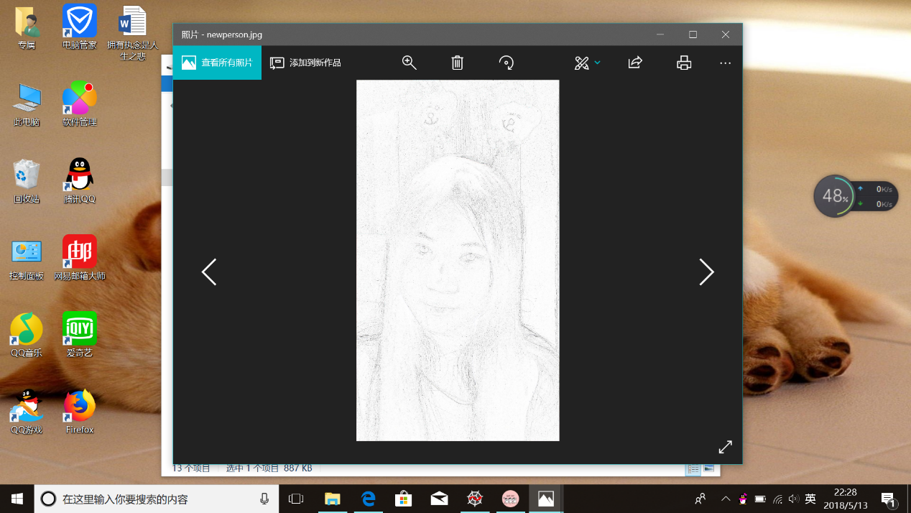

5.代码如下：

from PIL import Image

from PIL import ImageEnhance

im = Image.open('E:\\dog.jpg')

r, g, b = im.split()

newr = r.point(lambda i:i\*0.6)#将R通道颜色值变为原来的0.6倍

newg = g.point(lambda i:i<150)#选择G通道值低于150的像素点

bm = Image.merge("RGB",(newr,b,newg))

om = ImageEnhance.Contrast(bm)

om.enhance(10).save('E:\\dogps.jpg')

